# 3D objects

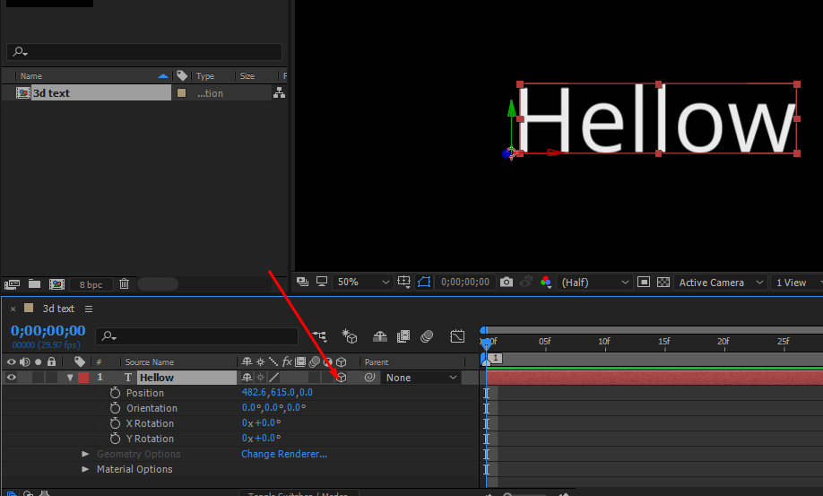

## Null Objects

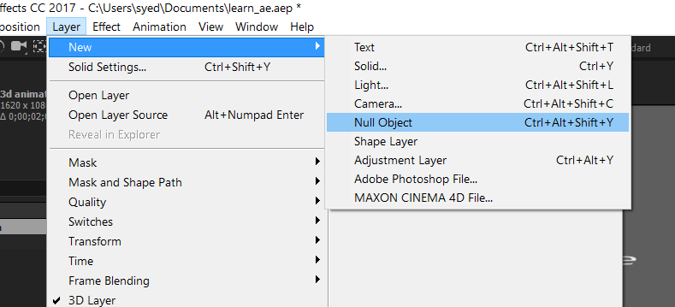

# Parenting

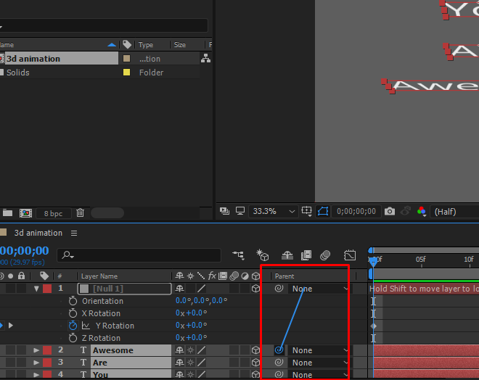

# Camera Tool

Use Camera Tool in conjunction with Null object.